**JAVA OPEN ENDED EXPERIMENT REPORT**

**TITLE: STUDENT WORKPLANNER**

The objective of the projectis to develop a student work planner which would help the student to take care about their day to day works

The planner is divided into various working hours (8am-10pm) for each day of the week with two different modes provided to user i.e. editable mode and non-editable mode. The non-editable modes are the college working hours which could only be filled once per semester. The editable modes are filled on a daily basis by the students.

**Concepts Used:**

Frontend: Java Swings

Programming Language: Java

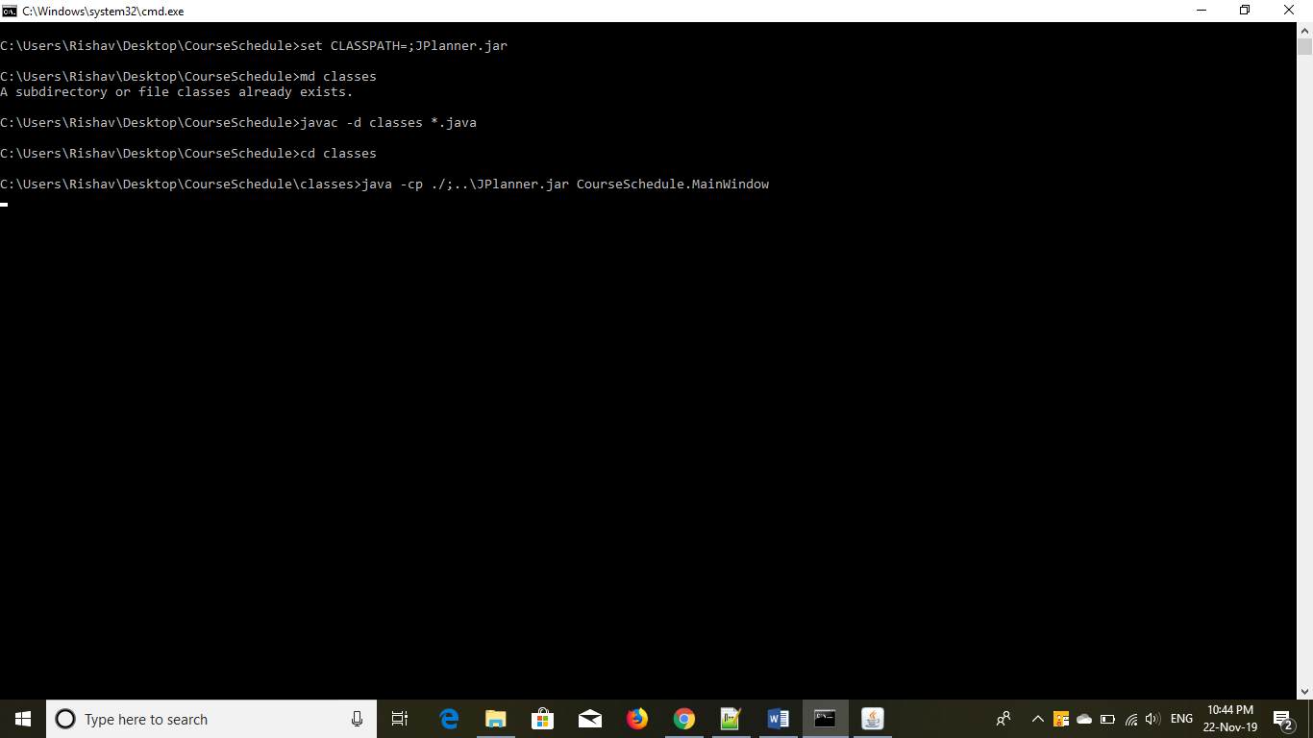

CODE TO EXECUTE THE PROGRAM.

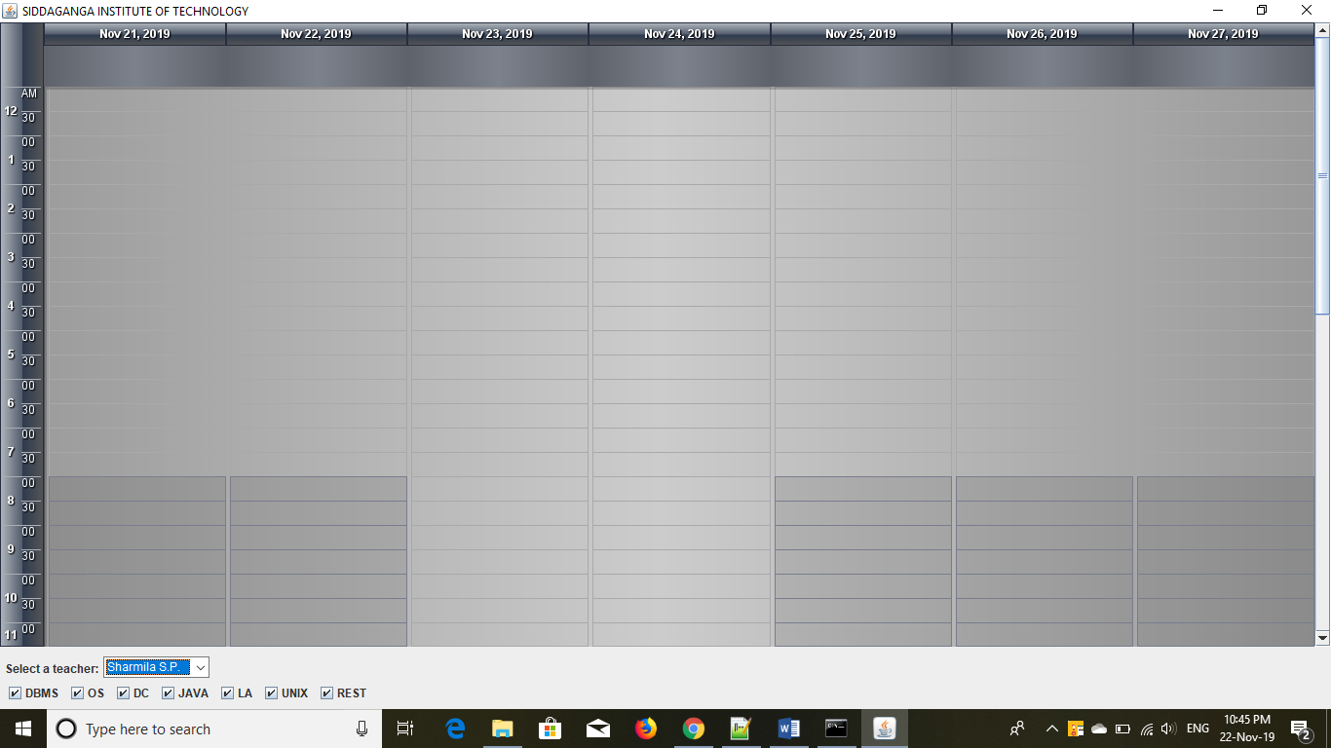

The first page where user provides their timetable as show:-.

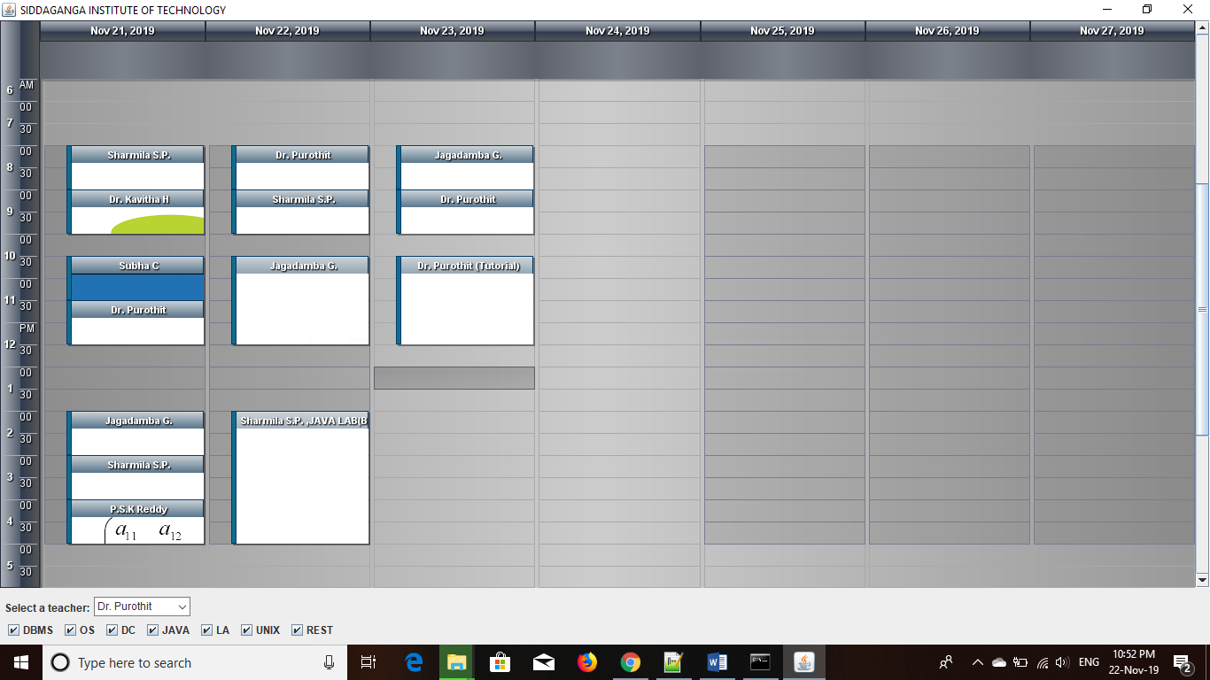

Editing of the pre-defined text could be done by double click on selected field.

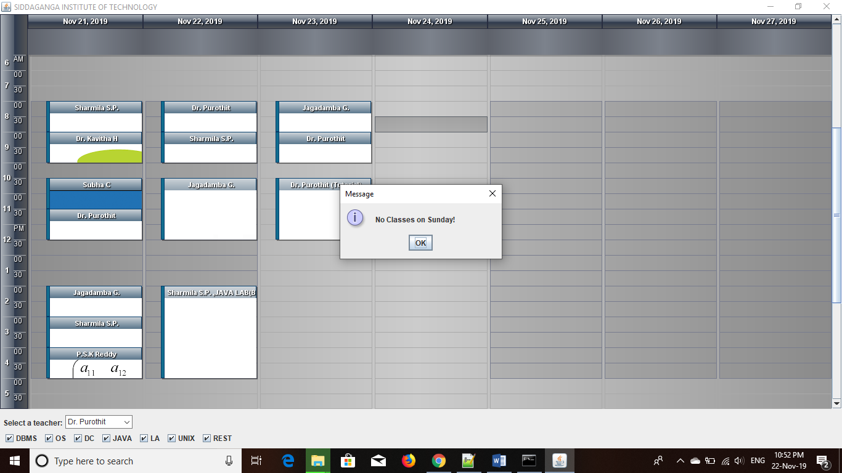

Users can’t enter Classes on Sunday

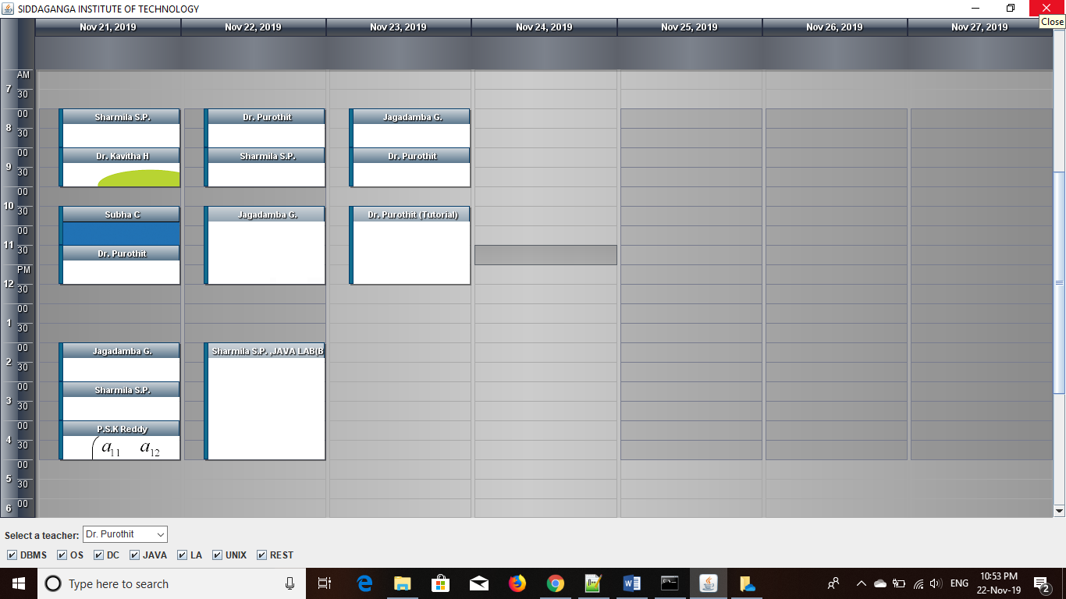

If program is closed it sent to work in the background as shown:-

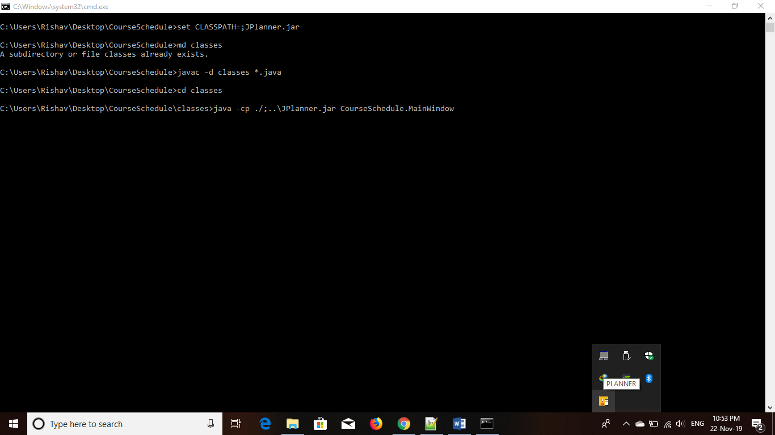

Members and their USN:-

1.Harsh Kumar 1SI17IS013

2.Kumar Rishav 1SI17IS017

3.Aditi Anshu 1SI17IS003

Submitted To:

Mrs. Sharmila S P

M.Tech.

Assistant Professor

Dept. of ISE, SIT, Tumakuru